COMSATS University
Islamabad
Attock Campus


Project Proposal

for

AI-driven Smart Review System using Blockchain
by

Muhammad Anas Malaika Mushtaq

CIIT/FA22-BSE-014/ATK CIIT/FA22-BSE-007/ATK

Supervisor

Dr. Yaser Ali Shah

Bachelor of Science in Software Engineering
(2022-2026)

AI-driven Smart Review System using Blockchain

By

Muhammad Anas CIIT/FA22-BSE-014/ATK

Malaika Mushtaq CIIT/FA22-BSE-007/ATK

As the supervisor, I have reviewed the proposed project and found it to be feasible, relevant, and aligned with the academic and industry standards. I recommend this project for evaluation by the committee to assess its viability and approval for further development.

Supervisor Signature:

Dr. Yaser Ali Shah
Department of Computer Science, (CUI) Attock Campus

Minutes of FYP Proposal Defense
Proposal Defense Date: ___________
Name & Reg. #: | Muhammad Anas(fa22-bse-014) & Malaika Mushtaq(fa22-bse-007)
Degree Program: | Bachelor in Software Engineering (BSE)
Previous Title: | AI-driven smart review system using block chain
New Title: | AI-driven smart review system using block chain (Unchanged).

Evaluation Comments | Response by the Student
what is the practical usability of your project. | Many fields can adopt the system like E-commerce, Food & Services.  For detail:  Please See section 10(page 11)
Why integrate AI with Blockchain? | AI filters pre-submission  Blockchain secures post-submission  For detail:  Please See section 4(page 4):
How detect fake reviews? | AI based detection:  Block chain-based detection:  For detail:  Please See section 7(page 6):
How detect fake Users? | Wallet-Based Identity (Sybil resistance):  CNIC based identity:  For detail:  Please See section 7(page 6):
Cloud deployment? | Its not a module its an infrastructure where we can deploy our project for scalability, reliability and easy maintenance.  For detail:  Please See section 9.6(page 10):
Smart contract usability? | We will use solidity for writing and programming the smart contracts

__________________________________
Supervisor Name and Signature

Project Summary:

The proposed study focuses on developing an AI and blockchain-based review system to address the limitations of traditional review platforms. The rationale behind this study stems from the growing need for transparency, accountability, and quality in online reviews, which are often plagued by fake feedback, lack of incentives, and inappropriate content. By integrating blockchain technology and AI-driven solutions, this system aims to create a decentralized, secure, and intelligent review platform.
The broader challenges in this research area include the prevalence of fake reviews, lack of trust in centralized systems, and the inefficiency of manual content moderation. Existing solutions, such as centralized review platforms and basic AI moderation tools, have partially addressed these issues but fail to ensure immutability, transparency, and user incentivization.
The proposed system fills these research gaps by leveraging blockchain to store reviews immutably and manage a cryptocurrency-based reward system. Additionally, AI algorithms will enhance the platform by suggesting review wording, detecting hate speech, and ensuring only constructive feedback is published. This combination of technologies addresses the problem formulation of creating a trustworthy, incentivized, and high-quality review ecosystem.
The objective of this study is to design and implement a decentralized review platform where businesses can register, reviewers are incentivized with coins, and AI ensures content quality. The methodology involves developing a blockchain-based backend, integrating AI modules for content analysis, and deploying the system on the cloud for scalability.
The significance of this work lies in its potential to revolutionize online reviews by ensuring transparency, fairness, and user engagement. It provides a novel solution for businesses to gain genuine feedback, reviewers to earn rewards, and users to access reliable information.

Contents
1 Introduction 2
2 Literature Review 3
3 Problem Statement 4
4 Problem Solution 4
5 Vision Statement 4
6 Scope 5
7 Methodology 6
8 System Limitations 6
9 Tools and Technologies 10
10 Applications of this Project 11
11 WBS and Gantt Chart 12
12 Mockups 13

1 Introduction:

In today’s digital age, online reviews play a pivotal role in shaping consumer decisions and business reputations. However, traditional review systems are often plagued by challenges such as fake reviews, lack of transparency, and ineffective content moderation. These issues undermine the credibility of reviews and hinder the ability of businesses to gain genuine feedback. To address these limitations, this project proposes an AI and blockchain-based review system that revolutionizes the way reviews are created, managed, and incentivized.
The proposed system leverages blockchain technology to ensure transparency, immutability, and security in storing reviews. By integrating a cryptocurrency-based reward mechanism, it incentivizes reviewers to provide high-quality feedback while allowing businesses to purchase coins to participate in the ecosystem. Additionally, AI-powered tools are employed to enhance the review process by suggesting constructive wording, detecting hate speech, and filtering out inappropriate content. This combination of technologies creates a decentralized, intelligent, and user-friendly platform that benefits all stakeholders’ businesses, reviewers, and consumers.
The significance of this project lies in its ability to address the core challenges of traditional review systems while introducing innovative solutions powered by cutting-edge technologies. By ensuring trust, fairness, and quality, this system has the potential to transform the online review landscape, making it more reliable and impactful for all users.

2 Literature Review:
Emerging technologies are reshaping digital trust systems, yet key synergies remain unexplored in review platforms.
- Converging Technologies: The Missing Triad
Current systems address only fragments of the challenge - blockchain secures data (Nakamoto, 2008), AI enables smart moderation (Devlin et al., 2019), and crypto incentivizes participation. However, isolated implementations (like Steemit's blockchain or Brave's rewards) create partial solutions vulnerable to manipulation or poor quality.
- Critical Research Gaps
The absence of integrated frameworks leaves platforms choosing between security (blockchain), intelligence (AI), or engagement (incentives) - never achieving all three simultaneously.
- Our Integrated Approach
This project pioneers a trifecta solution: blockchain's immutable ledger, AI's contextual understanding, and tokenized rewards - finally enabling truly trustworthy digital reviews.

Comparative Platform Analysis

Feature/ Criteria | Trustpilot | Steemit | Google Reviews | Proposed System
Trust Mechanism | Centralized (Company-controlled) | Decentralized (Community votes) | Centralized (Google-controlled) | Hybrid (Blockchain + AI verification)
Fake Review Prevention | Manual reporting + basic algorithms | No AI moderation | Algorithmic detection | NLP analysis +  on-chain immutability
Incentivization | No rewards | STEEM tokens for upvotes | No rewards | Base coins + bonus for likes
Moderation | Human + rudimentary AI | Community voting only | Automated filters | speech detection + constructive feedback scoring
Transparency | Company can remove reviews | Public blockchain | Google can alter visibility | IPFS + Blockchain storage
Scalability | High (Centralized servers) | Slow | High (Google Cloud) | Private blockchain/Layer 2 solution
User Control | Limited (Trustpilot owns data) | Users own content | Google owns data | Wallet-owned data + decentralized identity

Table 1: Feature Comparison of Review Platforms

3 Problem Statement:

In today's digital marketplace, online review systems suffer from systemic flaws that undermine their credibility. Rampant fake reviews and platform manipulation distort consumer perceptions, while centralized control enables selective censorship of negative feedback. The absence of meaningful incentives results in sparse, low-quality contributions, and inadequate moderation allows spam and abusive content to proliferate. Most critically, mutable records prevent verification of review authenticity. These interconnected issues demand a robust solution—our AI and blockchain-powered platform establishes trust through immutable records, intelligent moderation, and equitable incentive structures to revolutionize digital feedback systems.

4 Problem Solution:

Our solution integrates AI and blockchain to revolutionize review systems, combining blockchain's immutable ledger for tamper-proof transparency with AI-powered NLP for real-time content moderation that filters spam and hate speech while improving feedback quality. A cryptocurrency incentive system rewards high-quality reviews with exchangeable tokens, driving meaningful participation, while smart contracts automate fair reward distribution and validation processes. Deployed on scalable cloud infrastructure with microservices architecture, the platform ensures permanent, auditable record-keeping through blockchain timestamps and fosters community engagement via token-rewarded interactions - delivering a comprehensive ecosystem that simultaneously addresses authenticity (through decentralization), quality (via AI curation), and sustainable participation (through crypto-economics).

Our AI (using BERT) detects fake reviews by analyzing text patterns and behavior while improving content quality through neutral wording suggestions, but cannot prevent post-submission tampering - which is solved by blockchain that permanently stores approved reviews on-chain (IPFS + Ethereum) with tamper-proof transparency and automated token rewards, though blockchain alone cannot filter low-quality submissions before they enter the system.

5 Vision Statement:

We are building a paradigm shift in digital trust by merging blockchain’s immutability with AI’s analytical power to create the first truly transparent review ecosystem. This platform empowers businesses with authentic customer insights to refine their services, incentivizes reviewers through tokenized rewards for high-quality contributions, and equips consumers with verified, AI-curated feedback for confident decision-making. By decentralizing control through distributed ledger technology and implementing machine learning moderation, we eliminate manipulation while fostering organic community growth. Every stakeholder—from small businesses to individual reviewers—gains equitable participation in a self-regulating system where transparency and meritocracy replace opaque algorithms and biased content. Our solution doesn’t just improve reviews; it redefines digital accountability, setting new benchmarks for how information is created, validated, and consumed globally. This is more than a platform—it’s a movement toward ethical digital interactions, where every voice matters, every contribution carries weight, and trust is engineered into every transaction through cutting-edge technology.

6 Scope:

System Overview:
Our AI-blockchain review platform enhances feedback transparency and quality through three core pillars: blockchain immutability, AI moderation, and crypto-incentives. Businesses register and purchase platform coins to access authentic feedback, while reviewers earn coins for quality contributions, with bonus rewards for high engagement. The system features AI-driven content analysis (sentiment evaluation, hate speech detection, and writing suggestions) and blockchain infrastructure (tamper-proof records, smart contracts for automated rewards/validation).

Implementation & Deliverables:
The solution includes: a responsive web interface, Ethereum/Hyperledger blockchain integration, AI moderation modules, admin dashboard, and cloud deployment package - focusing exclusively on core functionality (review/reward systems, basic AI/blockchain features) without developing new protocols or advanced financial tools.

Objectives:
We deliver a scalable system that solves traditional platforms' flaws by ensuring:
(1) Transparent feedback via blockchain,
(2) Curated quality through AI,
(3) Sustainable participation via tokenized incentives
specifically targeting Trustpilot's limitations while prioritizing immediate, measurable value.

7 Methodology:

AI-based detection (for fake reviews):
Using BERT AI, we analyze review text for duplicates and off-topic content, monitor for unnatural posting patterns, and implement a tiered trust system that fast-tracks reliable reviewers while carefully screening new accounts

Block chain-based detection (for fake reviews):
Our blockchain creates an unchangeable record of every review (visible as hashes on-chain), where timestamps expose manipulation attempts - like detecting a flood of reviews submitted within minutes (impossible due to blockchain's 10-minute confirmation time) which automatically flags them as suspicious.

Detecting Sybil Attacks (for fake Users):
User identity is secured via wallet authentication (50+ coin stake) paired with CNIC validation, creating a Sybil-resistant system where each national ID can only register one account while preserving pseudonymity.

1. Planning & Analysis
- Gather requirements via stakeholder interviews (businesses/reviewers)
- Define core functional needs (transparency, rewards, moderation) and technical specs
2. Architecture & Design
- Design full-stack architecture (React/Django frontend, Node.js/Python backend)
- Structure blockchain integration (Ethereum smart contracts for rewards/validation)
- Model AI workflows (Hugging Face NLP for content quality/hate speech detection)
3. Development & Integration
- Build responsive UI with modular components
- Develop/train AI models for real-time feedback analysis
- Deploy blockchain contracts for immutable review storage
- Integrate microservices via APIs
4. Testing & Deployment
- Rigorous QA: unit → integration → UAT testing
- Cloud deployment (AWS) with CI/CD pipelines
- Continuous monitoring for performance/security

List of Modules in our project:

1. User Registration and Authentication:
Allows business owners and reviewers to register and log in.
Ensures secure access to the system.
2. Business Registration:
Enables business owners to register their business on the platform.
Stores business details (name, category, location, etc.).
3. Coin Management:
Allows business owners to buy coins from the admin.
Manages coin balances for users (business owners and reviewers).
4. Review Submission:
Allows reviewers to write and submit reviews for businesses.
Integrates AI for wording suggestions and hate speech detection.
5. AI Module:
Wording Suggestions: Suggests better wording for reviews based on past data.
Hate Speech Detection: Analyses reviews to filter out inappropriate content.
6. Blockchain Integration:
Stores reviews on the blockchain for transparency and immutability.
Manages coin transfers via smart contracts (e.g., 1 coin per review).
7. Like and Reward System:
Allows other users to like reviews.
Awards additional coins to reviewers if their review gets a certain percentage of likes.
8. Admin Dashboard:
Allows the admin to manage businesses, reviewers, and coin distribution.
Monitors reviews and resolves disputes.
9. Wallet Integration:
Manages cryptocurrency wallets for users (business owners and reviewers).
Handles coin transfers and balances.

Flow Chart:
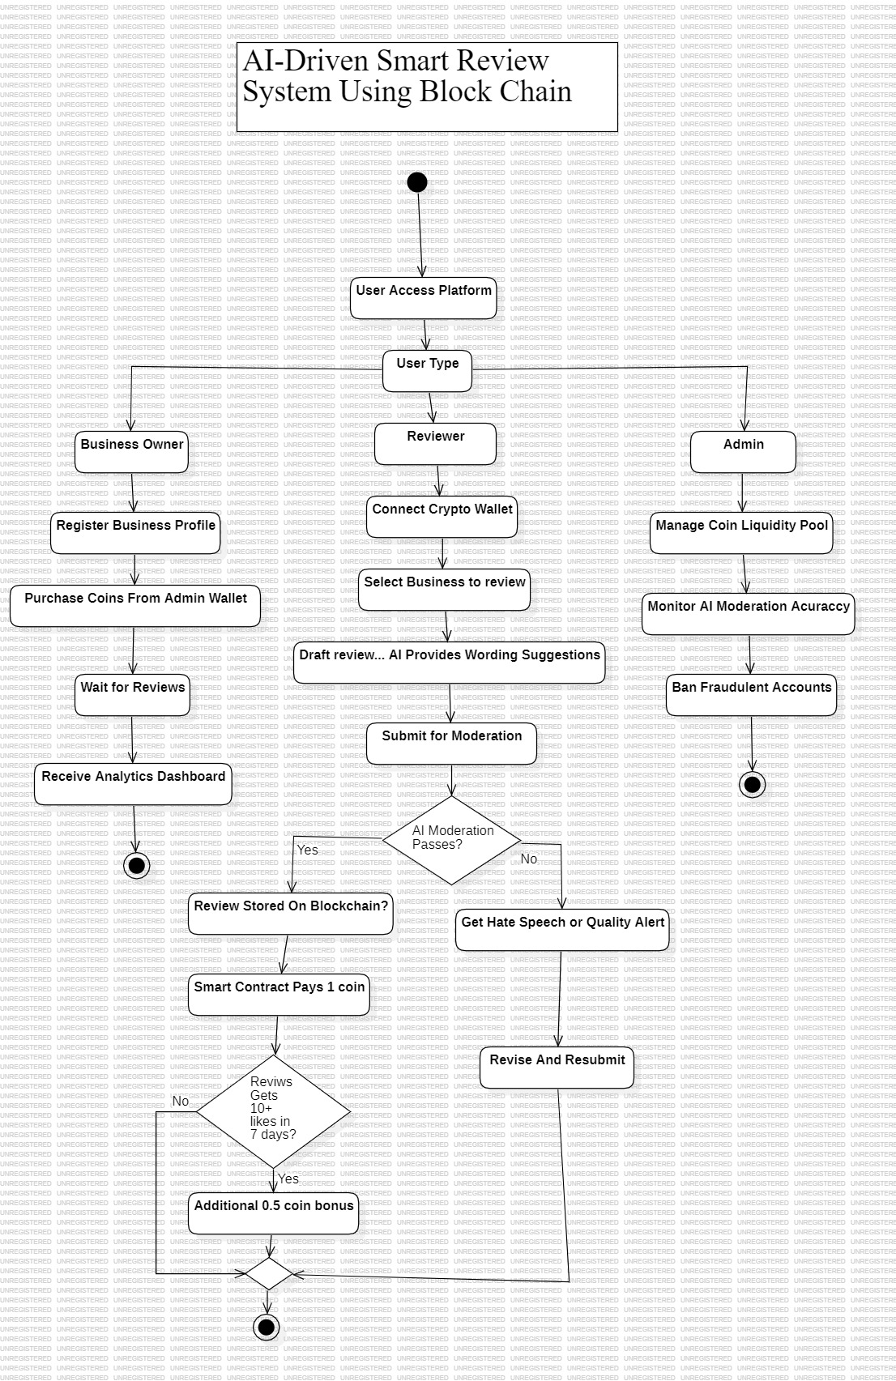
Figure 1: Flow chart

8 System Limitations:
Technical & Operational Constraints:
- Blockchain Limitations
  - Scalability bottlenecks during peak usage
  - Variable transaction fees (especially on Ethereum)
  - Energy-intensive consensus mechanisms (PoW)
- AI Implementation Risks
  - Training data quality dependencies
  - Moderate false-positive rates in content filtering
  - Unintended bias in automated evaluations
- Adoption Hurdles
  - Cryptocurrency literacy gap among mainstream users
  - Infrastructure demands (consistent high-speed internet)
  - Regulatory fragmentation across jurisdictions
- Development Complexities
  - Cross-domain integration (AI + blockchain + cloud)
  - Extended timelines for secure interoperability
  - Talent scarcity in full-stack Web3 development

9 Tools and Technologies:
Technical Stack Overview:
- Blockchain Infrastructure
  - Platforms: Ethereum (public), Hyperledger Fabric (private)
  - Smart Contracts: Solidity (ETH), Chain code (HLF)
  - Storage: IPFS for decentralized data
  - Wallets: MetaMask integration + custom solutions
- AI/ML Implementation
  - NLP: Hugging Face Transformers, SpaCy pipelines
  - Moderation: BERT/GPT models via TensorFlow/PyTorch
  - Support: Scikit-learn for traditional ML tasks
- Frontend Ecosystem
  - Core: React.js/Angular with TypeScript
  - Styling: Material-UI + Bootstrap
  - State: Redux/NgRx for complex management
- Backend Services
  - Frameworks: Node.js (Express) or Django
  - APIs: REST/GraphQL endpoints
  - Auth: JWT/OAuth 2.0 flows
- Data Management
  - Decentralized: OrbitDB/BigchainDB
  - Traditional: MongoDB (NoSQL), PostgreSQL (RDBMS)
- Cloud & DevOps
  - Providers: AWS ECS, Google Cloud Run
  - Containers: Docker with Kubernetes orchestration
  - CI/CD: GitHub Actions pipelines
  - Monitoring: Prometheus + Grafana dashboards
While not a standalone module, we utilize cloud platforms (AWS/Google Cloud) as critical infrastructure to host our AI models, blockchain nodes, and backend systems - providing the necessary scalability for growing users, cost-efficient computing power for blockchain operations, enterprise-grade security, and reliable performance for real-time AI processing, mirroring how Salah et al. leveraged IPFS for decentralized storage infrastructure in their implementation.

10 Applications of this Project:

Unlike existing platforms (Trustpilot, Steemit) that lack AI refinement and secure storage, our system serves all review-dependent industries - from e-commerce (Amazon, Daraz) to hospitality (Airbnb) and food services (Zomato) - using AI to improve review quality and blockchain for tamper-proof storage, creating real-world impact where consumers get trustworthy feedback, businesses compete fairly, and platforms gain credibility through reduced fraud.

Cross-Industry Applications & Benefits:
E-Commerce
- Fraud-proof product reviews
- Verified seller reputation tracking
- Incentivized customer feedback loops
Hospitality & Healthcare
- Tamper-evident service evaluations (hotels/clinics)
- Quality benchmarking through authenticated patient/guest reports
Education & Gig Economy
- Unalterable course/instructor ratings
- Trust-based freelancer-client review exchanges

Strategic Advantages:
✓ Universal Trust Framework
- Blockchain-verified authenticity across all reviews
- AI-filtered content quality assurance
✓ Sector-Specific Value
- Businesses: Credible reputation metrics
- Platforms: Reduced moderation overhead
- Users: Reliable decision-making data
✓ System-Wide Benefits
- Tokenized incentives driving engagement
- Immutable audit trails for compliance
- Scalable across industries via modular design

11 Gantt Chart and WBS:

Gantt Chart:
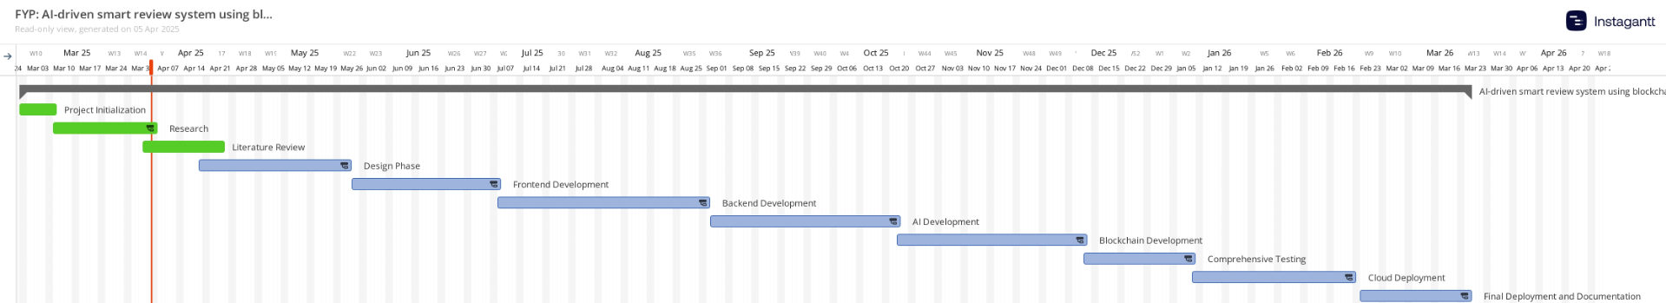

Figure 1: Gantt Chart of the project

WBS:

ID | Task | Duration
1 | User Management (M1 + M2 + M8) | 28 days
1.1 | Reviewers Authentication (M1) | 7 days
1.2 | Business Registration (M2) | 7 days
1.3 | Wallet Integration (M8) | 14 days
2 | Core Functionalities (M4 + M5 + M6 + M7) | 70 days
2.1 | Review Submission (M4) | 14 days
2.2 | Ai Modules (M5) | 20 days
2.3 | Block chain integration (M6) | 24 days
2.4 | Like reward (M7) | 12 days
3 | Admin & Infrastructure (M3 + M10) | 62 days
3.1 | Admin dashboard (M3) | 20 days
3.2 | Testing and Debugging (M10) | 20 days
3.3 | Cloud deployment | 15 days
3.4 | Final documentation | 7 days

Table 2: WBS of the Project

12 Mockups

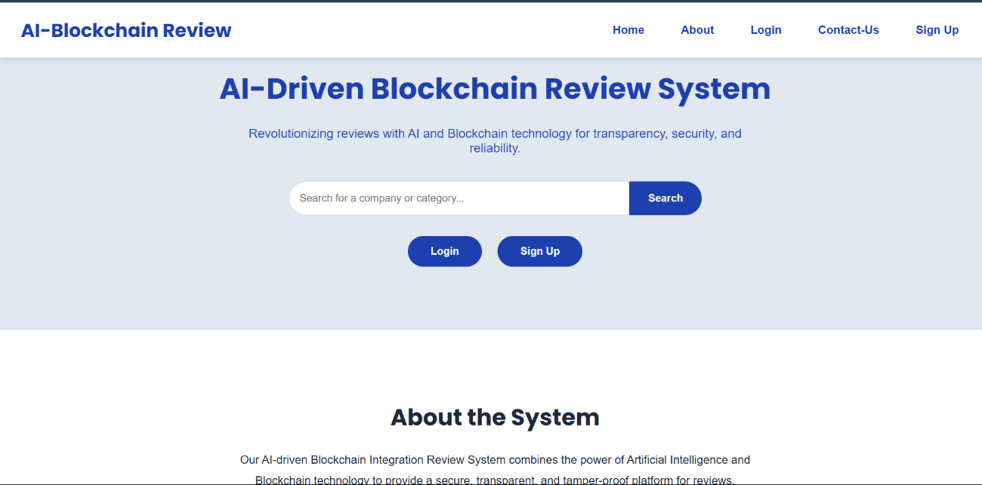

Figure 1: Home Screen

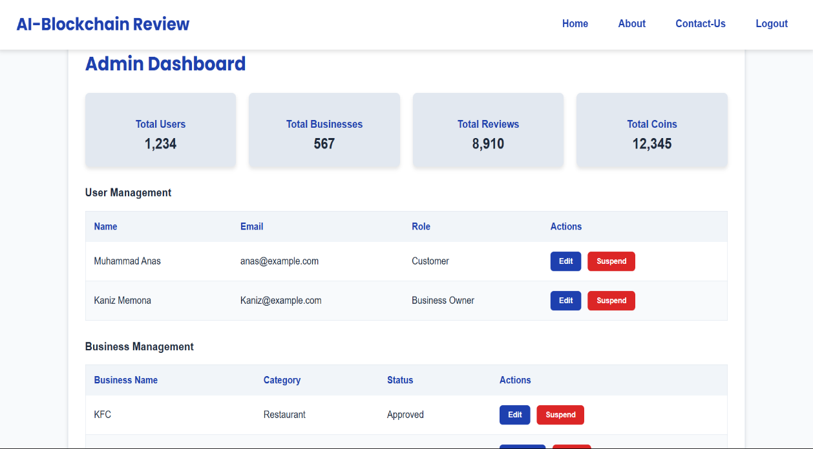

Figure 2: Admin Dashboard

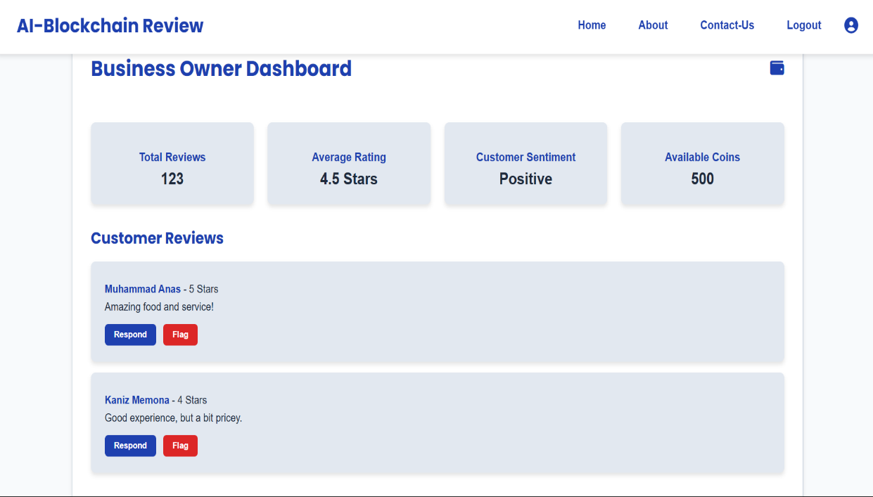

Figure 3: Business Owner Dashboard

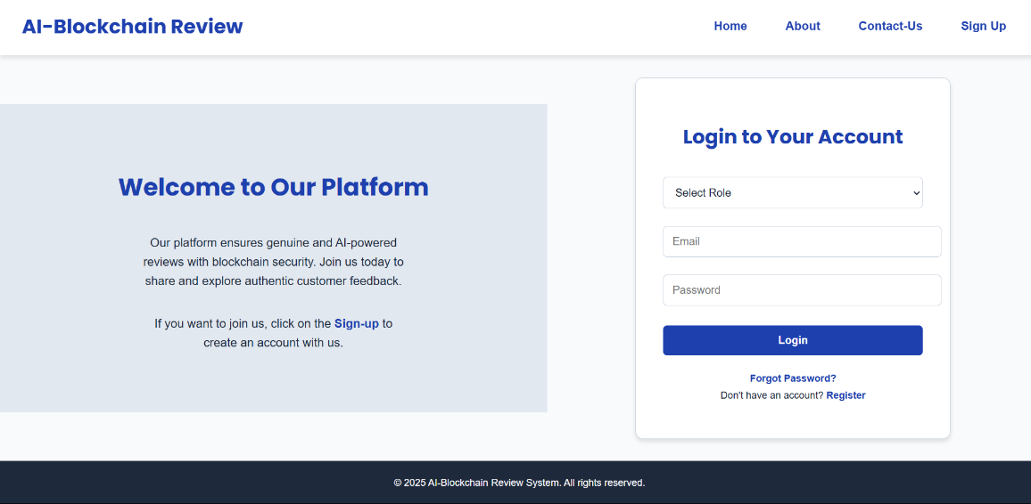

Figure 4: Login Page

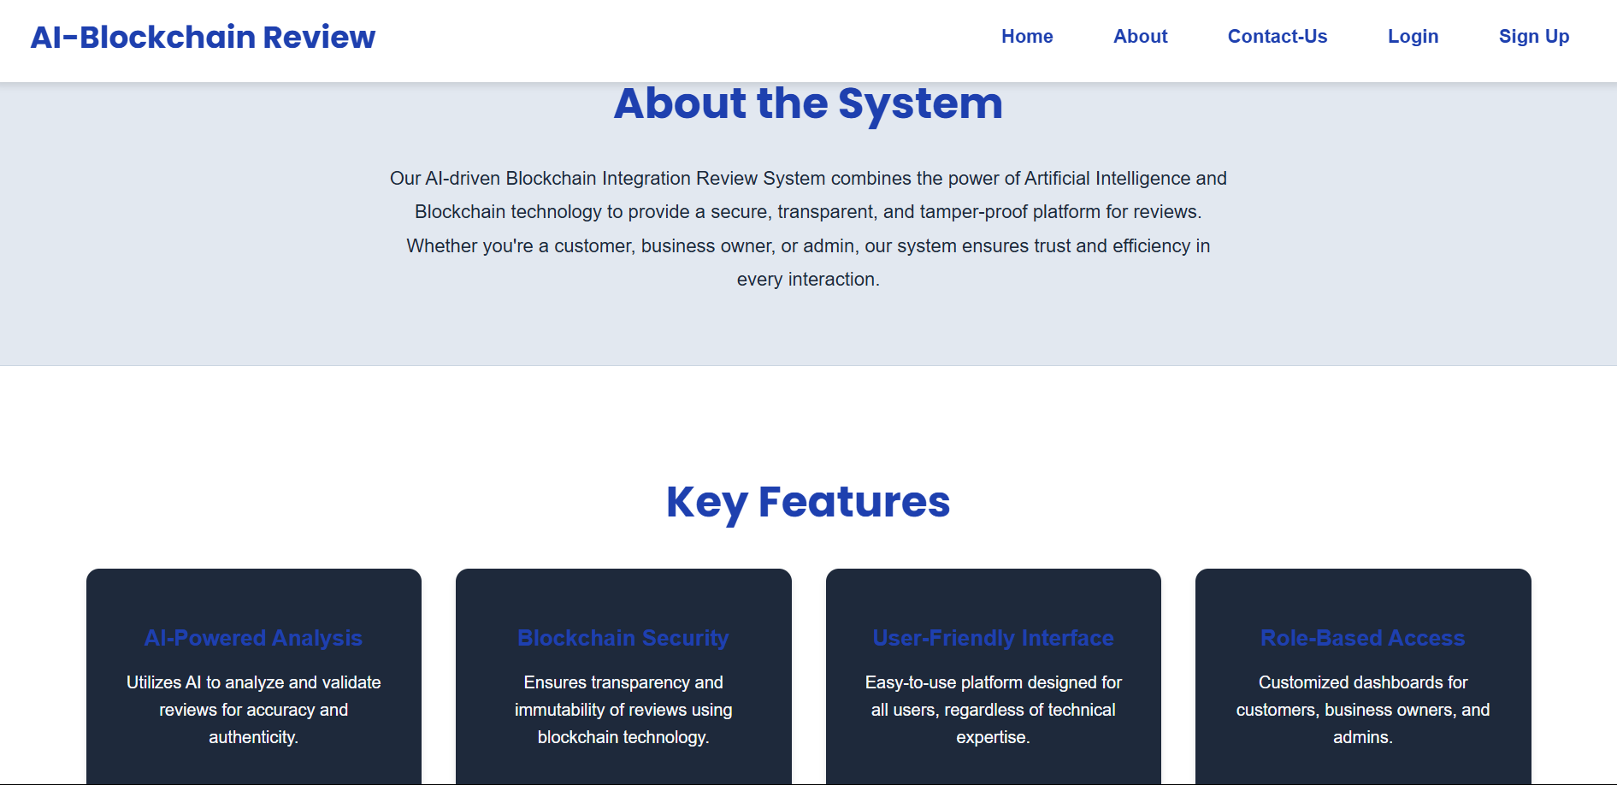

Figure 5: About the system

